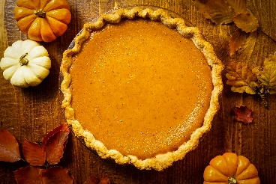
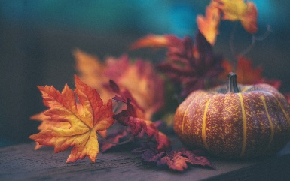
November Menu

Sun. | Mon. | Tue. | Wed. | Thu. | Fri. | Sat.
Apple Juice & Water served with snacks
Milk & Water served with lunch
Snacks: Wheat thin, Ritz, Club, Graham, Goldfish, Fishy Graham Crackers.
1 | 2 | 3 | 4 | 5 | 6 | 7
 | Chicken A La King  Mixed Vegetables  Peaches | Fish Sticks  Green Beans  Pineapple | Beef Stew  Mixed Vegetables  Apple Sauce | Cheese casserole  Carrots  Pears | Cheese Pizza  Peas  Oranges
8 | 9 | 10 | 11 | 12 | 13 | 14
 | Chicken Alfredo  Peas  Peaches | Macaroni & Cheese  Carrots  Pineapple | Spaghetti & Meatballs  Green Beans  Oranges | Cheese Quesadillas  Mixed Vegetables  Pears | Chicken Nuggets  Peas  Apple Sauce
15 | 16 | 17 | 18 Thanksgiving  FFr | 19 | 20 | 21
 | Chicken A La King  Mixed Vegetables  Pears | Fish sticks  Green Beans  Peaches | Turkey & Stuffing Rolls  Mixed Vegetables Potatoes  Applesauce Pumpkin Pie | Spaghetti & Meatballs  Carrots  Pineapples | Cheese Pizza  Peas  Oranges
22 | 23 | 24 | 25 | 26 | 27 | 28
 | Cheese Casserole  Carrots  Pears | Chicken A la King  Mixed Vegetables  Apple Sauce | Cheese Quesadillas  Green Beans  Peaches | Pizza Casserole  Peas  Pineapples | Chicken Nuggets  Carrots  Oranges
29 | 30
Chicken Alfredo
Peas
Pineapples

